Weekly Construction Progress Report – Week 15
Harrow Bay Offshore Wind · 06 Apr – 12 Apr 2026
Elena Márquez · 13 April 2026 · HB-PM-RPT-2026-W15

1. Summary
2 monopiles (HB-A01, HB-A02) were installed this week, bringing the total to 2 of 40. The foundation campaign is 1 pile ahead of the Rev 2 baseline. Waiting on weather amounted to 6 hours.
Area | Status | Comment
Overall schedule | Green | 2/40 monopiles vs. 1 planned
Foundations | Green | TPs installed: 1
Offshore substation | Green | Fabrication / load-out
Cables | Green | Manufacturing on schedule
HSE | Green | No incidents

2. Progress
Metric | This week | Cumulative | Plan (cum.) | Variance
Monopiles installed | 2 | 2 | 1 | +1
Transition pieces installed | 1 | 1 | – | –
Waiting on weather (h) | 6 | 6 | – | –
Persons on board (avg.) | 98 | – | – | –
Man-hours MV Sea Atlas | 8,416 | 8,416 | – | –
Lost time injuries | 0 | 0 | 0 | 0
Recordable injuries | 0 | 0 | – | –
Near misses reported | 0 | 0 | – | –
HSE observation cards | 15 | – | – | –

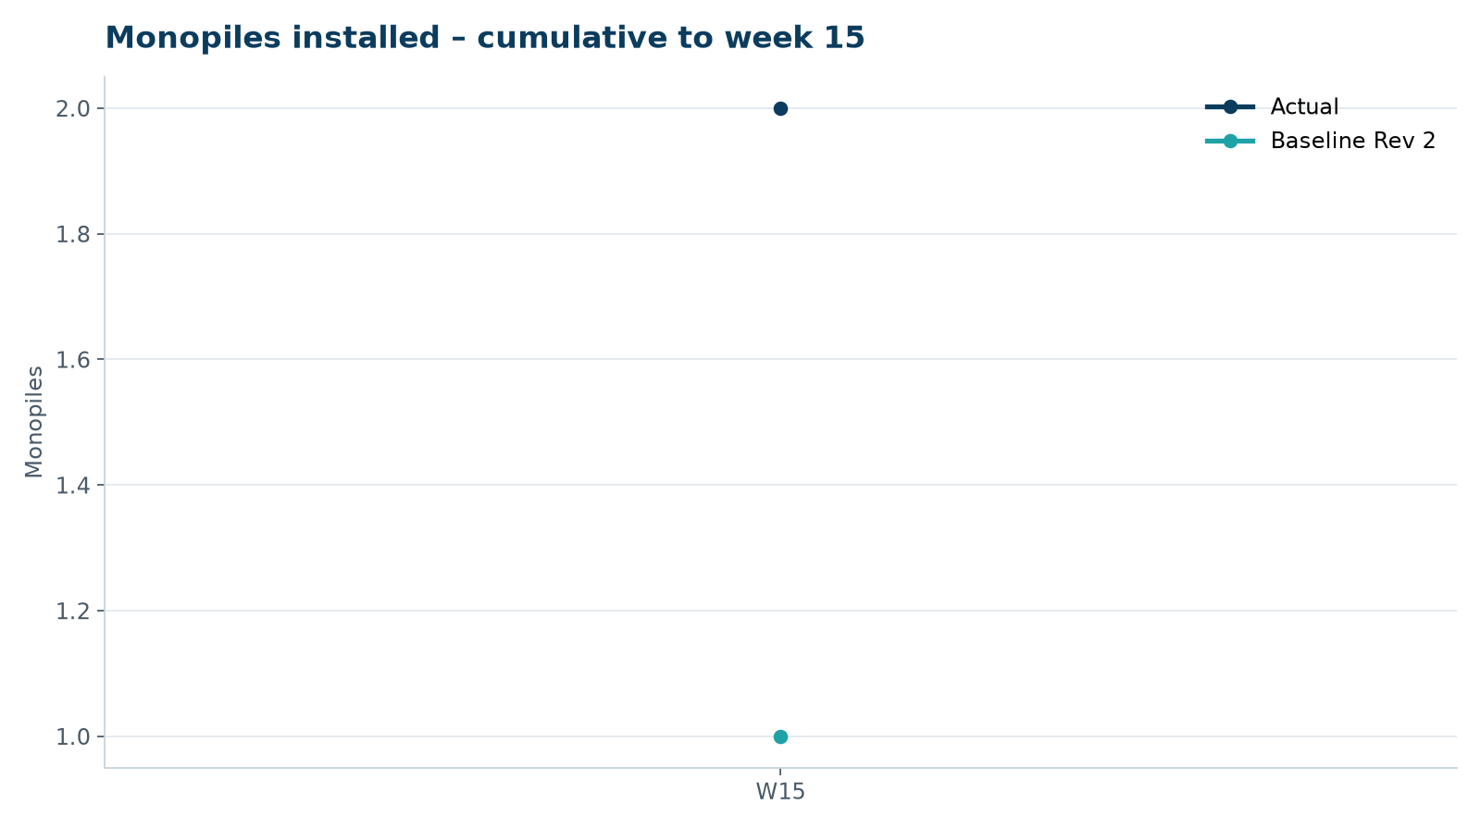
Figure 1 – Monopile installation progress, W15 to W15

3. Key activities this week
- Offshore construction started on 7 April: HB-A01 was the first monopile installed, driving completed at 14:20 after 3 h 52 min.
- First deployment of the double big bubble curtain (DBBC); peak noise at 750 m measured at 158.4 dB SEL, below the 160 dB consent limit.
- HB-A02 installed on 12 April; transition piece HB-A01 bolted on 9 April.
- Dr. Amara Okafor and Jonas Richter visited the Port of Eastholm base on 8 April.

4. Health and safety
No lost time injuries. 15 observation cards submitted; top theme: housekeeping on the main deck.

5. Environment
- HB-A01: peak 158.4 dB SEL at 750 m (compliant); harbour porpoise detected in the mitigation zone during the pre-piling search, soft start delayed by 12 min.
- HB-A02: peak 157.9 dB SEL at 750 m (compliant); pre-piling search clear, soft start on time.

6. Issues and risks
- HB-RISK-001 weather: 6 h downtime this week.

7. Look-ahead next week
Install HB-A03 and HB-A04; first noise monitoring report to the regulator.
Prepared by Project Controls (Gareth Lewis); approved by Elena Márquez. Distribution: project team, Steering Committee, Halden Turbine Systems, Lenders' Technical Adviser.

